EOForge
What it does (version 0.6.0)
Nuno César de Sá · 21 October 2026

Summary
EOForge is a Python tool for running deep learning models on satellite imagery. It does two things. It runs ready-made models (land cover, field boundaries, floods, burn scars, clouds, object outlines) on your own images from a local web app, and shows the result on a map. And it trains your own models from an image and labels, with any architecture, and writes georeferenced maps with a per-pixel uncertainty map.
Today it can:
- Run eleven published models from a model zoo: Dynamic World, TerraMind, Fields of The World, Delineate Anything, two Prithvi-EO-2.0 fine-tunes, OmniCloudMask and SAM 2, plus every model you trained.
- Show results in a web app: pick an image and a model, run it on the GPU, see the map on a satellite basemap with a legend of class areas, an uncertainty layer and downloads.
- Check the input before a model runs: units, the Sentinel-2 offset introduced in 2022, pixel size, missing or unnamed bands.
- Add models you come across with a short model card, or an ONNX file from the app.
- Train and fine-tune your own models on one or several images, with built-in, timm or your own architectures.
- Validate honestly with spatially separated blocks or whole held-out images, and report overall accuracy, kappa and per-class scores.
- Get started with public data: one command downloads Sentinel-2 scenes, a reference land-cover map and flood chips for any area, with step-by-step instructions.
It runs on your workstation (WSL with a GTX 1070) and is ready to publish on GitHub under the MIT licence. It has been tested on synthetic data, on Sentinel-2 from Slovenia and Zambia, and on ten LandCoverNet chips from southern Africa.

Running ready-made models

The web app
eoforge app --folder <your images> starts a local web page (http://localhost:8501). The sidebar has four steps:
- Image. Any GeoTIFF in the folder, or one you upload.
- Model. The built-in models, your own model cards, and every model you trained under the folder. The expected input (sensor, processing level, pixel size) is shown, and a missing package gives its install command.
- Bands. Matched by name (B2 = B02 = blue, NIR = B08 and so on). Images without band names are read in Sentinel-2 order, missing bands get stand-ins with a note, and any band can be set by hand. Two-date models get a start-of-season and an end-of-season choice.
- Run. Device, tile size, probabilities, an offset to subtract and resampling to the model's pixel size.
The result opens on a satellite basemap with an opacity slider, an uncertainty layer, a legend with the share and hectares of each class, the number of field polygons for the field models, and download buttons. Earlier runs can be reopened. The same runs are available from the command line (eoforge zoo run).

Models in the zoo
Model | What it does | Input it expects
Dynamic World (Google) | Land cover, 9 classes; included as an ONNX file | Sentinel-2 L1C, 9 bands, 10 m
TerraMind (IBM, ESA) | Generated land cover in Esri's 10 classes | Sentinel-2 L2A, 12 bands
Fields of The World (3 variants) | Field, field boundary, background; field polygons | Sentinel-2 L2A, red, green, blue, NIR, two dates (or one)
Delineate Anything (2 variants) | One polygon per field | True colour, 0.25-10 m
Prithvi-EO-2.0 floods | Water and floods (Sen1Floods11) | Sentinel-2 L1C, 6 bands
Prithvi-EO-2.0 burn scars | Burned areas | HLS, 6 bands, 30 m
OmniCloudMask | Clear, thick cloud, thin cloud, shadow | Red, green, NIR, 10-50 m
SAM 2 (Meta) | Object outlines, no class names | Any true colour, best below 2 m
Your trained models | Your classes | As trained
Table 1. Models in the zoo. Weights download on first use (about 4 GB in total); install.sh fetches them all at once.

Input checks
Most failures of ready-made models come from data that differ from their training data. Before each run EOForge:
- scales reflectance stored as 0-1 to the 0-10,000 range every model expects;
- subtracts the +1000 offset in Sentinel-2 data processed since January 2022 when asked, and warns when the data look like they carry it;
- resamples to the model's pixel size when asked, for example 10 m Sentinel-2 to the 30 m burn-scar model;
- warns when the pixel size is far from the model's, when a trained model meets bands far from its training data, and when the normalised input does not fit a TerraTorch model.
Warnings appear in the app and in summary.json. A guide lists, for every model, the data it needs and test sets with reference labels.

Adding a model
A model card is a short YAML file: bands, classes and colours, normalisation, where the weights are (a file, a URL or a Hugging Face repository) and which adapter runs it. ONNX models can be added from the app's *Add a model* tab without writing anything. Models that need their own code get a small adapter class; eight exist, covering ONNX, TerraTorch, TerraMind, the two field models, OmniCloudMask, SAM and EOForge's own checkpoints.

Outputs of a model run
File | Content
classes.tif / objects.tif | Class map with colour table and class names, or one id per object
entropy.tif | Uncertainty per pixel, 0 (certain) to 1 (all classes equally likely)
fields.gpkg / objects.gpkg | Polygons for the field models and SAM, with area
probabilities.tif | Optional: one band per class
summary.json | Model, bands used, warnings, run time, area of each class
preview_*.png | Map previews used by the app
Table 2. Written to <image folder>/eoforge_results/<image>__<model>/.

Training your own models
A run is described in one YAML file and goes through the same steps whatever the data or the model:
- Configuration. Image(s), labels, model and training settings. Misspelled settings stop the run with a clear message.
- Imagery. One image, or several listed under scenes, each with its own labels. Bands are standardised with statistics pooled over all images. Pixels without data are excluded.
- Labels. Polygons and points are burned onto the image grid; label rasters are resampled onto it. Unlabelled pixels are ignored, so sparse field points work as well as wall-to-wall maps.
- Split. Either square blocks within each image are held out, so test pixels are never neighbours of training pixels, or whole images are held out (val_scenes), which tests transfer to places the model has never seen.
- Model. Built and checked with a test input before training starts.
- Training. Small chips are sampled around labelled pixels, evenly across classes and images, with flips, rotations and random changes in band brightness, so the model depends less on one image's exact values. The epoch with the lowest validation loss is kept.
- Final check and maps. The best model maps every image; every held-out pixel is scored, and maps and scores are written to disk.
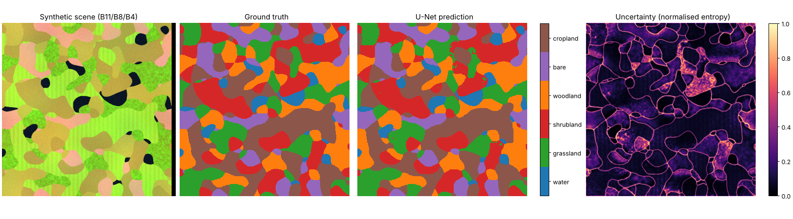
Figure 1. Synthetic test scene: image, ground truth, U-Net prediction and uncertainty. Errors concentrate where uncertainty is high.

Architectures
Any architecture can be used if it follows one rule: a function receives the number of bands and classes and returns a network that gives one score per class per pixel. The tool checks this when it builds the model.
Route | How to name it | Use
Built-in | unet, fcn | Any number of bands; small and fast
timm encoders | timm:resnet18, timm:efficientnet_b0 ... | Hundreds of proven encoders with a segmentation decoder; ImageNet weights adapted to your bands
Your own file | my_models.py:build | Any PyTorch network you write
Table 3. Ways to bring an architecture.
Fine-tuning. A run can start from an earlier model. Everything that fits is loaded; parts that do not, such as an output layer for a different number of classes, are trained from scratch. The encoder can be frozen so only the decoder learns.

Outputs of a training run
File | Content
best.pt / last.pt | The model with everything needed to reuse it: architecture, classes, bands, normalisation
metrics.json | Overall accuracy, kappa, macro-F1, producer's and user's accuracy per class, confusion matrix, per-image scores, training history
prediction/classes.tif, entropy.tif | Map and uncertainty of each image
model.onnx | Optional export for offline use (eoforge export)
Table 4. Written to runs/<name>/. Trained models appear in the app automatically.

Safeguards built in
- Spatial validation. Random pixel splits overstate accuracy on satellite data because neighbouring pixels are nearly identical. EOForge holds out whole blocks or whole images.
- Input checks for the zoo, described above.
- Band-shift warning. When a trained model is applied to a new image, each band is compared with the training data; bands more than two standard deviations away are flagged.
- Bands by name. A trained model picks its bands by name in a new image, so a different band order does not silently produce nonsense.
- Stable checkpoint choice by validation loss, which is less noisy than accuracy-based scores when some classes are rare.
- Class balancing by sampling chips evenly across classes. Loss weighting is available but off by default, because both together over-predict rare classes.
- Strict configuration. Typos and models that break the architecture rule fail at once, not after an hour of training.

Using it
Install once, then use the app or the command line:
bash install.sh /mnt/d/venvs/eoforge # once: PyTorch, models, weights
source /mnt/d/venvs/eoforge/bin/activate
cd /mnt/d/EOForge/eoforge
eoforge app --folder . # http://localhost:8501
python tools/get_tutorial_data.py # public sample data
eoforge zoo run dynamic-world scene.tif # one model, command line
eoforge train configs/real_s2_timm.yaml # train, validate, map
eoforge predict runs/x/best.pt new.tif # apply a trained model
The GTX 1070 needs PyTorch 2.14 with CUDA 12.6, the last release that supports its generation; install.sh pins it. Newer GPUs use a newer build (TORCH_CUDA=cu128 bash install.sh). Everything also runs on a CPU, more slowly.

Tutorial and sample data
tools/get_tutorial_data.py downloads, for one area (default: farms and miombo woodland north of Lusaka, Zambia), four Sentinel-2 L2A scenes chosen by their cloud mask inside the area (start of season, end of season, fire season, partly cloudy), the ESA WorldCover 2021 map on the same grid, and two hand-labelled flood chips from Sen1Floods11. No account is needed. It writes TUTORIAL.md with one step per model, and a training configuration that uses WorldCover as labels. tools/compare_maps.py compares any result with a reference map.
Model | Test data with reference labels
Dynamic World | Dynamic World test and expert validation tiles (Zenodo); Sentinel-2 L1C from Earth Engine
TerraMind | TerraMesh validation split; Esri 10 m land cover
Fields of The World, Delineate Anything | Fields of The World chips for Kenya, Rwanda and South Africa; AI4Boundaries
Prithvi floods | Sen1Floods11 hand-labelled chips
Prithvi burn scars | HLS Burn Scars; for Africa, HLS images with MODIS burned area
OmniCloudMask | CloudSEN12 (same four classes)
SAM 2 | OpenAerialMap drone and aerial imagery
Table 5. Recommended test data per model (details in the documentation).

Tests so far

1. Synthetic data
A generated six-band scene with six classes and known ground truth everywhere, used to check that the training pipeline works. All four model routes reached 0.98-0.99 held-out accuracy. On a second, unseen synthetic scene the map agreed with the truth on 95% of pixels. Mean uncertainty was 0.16 on correct pixels and 0.63 on wrong ones, so the uncertainty map does point to errors. Exported ONNX models matched PyTorch exactly.

2. Real Sentinel-2, Slovenia
Sentinel-2 imagery (13 bands, 68 dates over 2015-2017) of about 1 km² in Slovenia, with official land-use polygons, as April-October composites for 2016 and 2017. Five models and a Random Forest baseline were each run on three spatial splits; each 2017 model was also applied to 2016.
Model | Kappa 2017 | Kappa 2016 (other year) | Overall accuracy 2017
U-Net | 0.48 ± 0.07 | 0.49 ± 0.16 | 0.77 ± 0.10
FCN | 0.40 ± 0.03 | 0.41 ± 0.11 | 0.71 ± 0.11
Custom (my_model.py) | 0.50 ± 0.02 | 0.51 ± 0.09 | 0.77 ± 0.11
timm ResNet-18 | 0.51 ± 0.05 | 0.56 ± 0.02 | 0.81 ± 0.08
U-Net 2016 -> fine-tuned 2017 | 0.51 ± 0.07 | 0.55 ± 0.13 | 0.80 ± 0.08
Random Forest, per pixel (baseline) | 0.57 ± 0.03 | 0.60 ± 0.04 | 0.84 ± 0.07
Table 6. Mean ± standard deviation over three spatial splits.
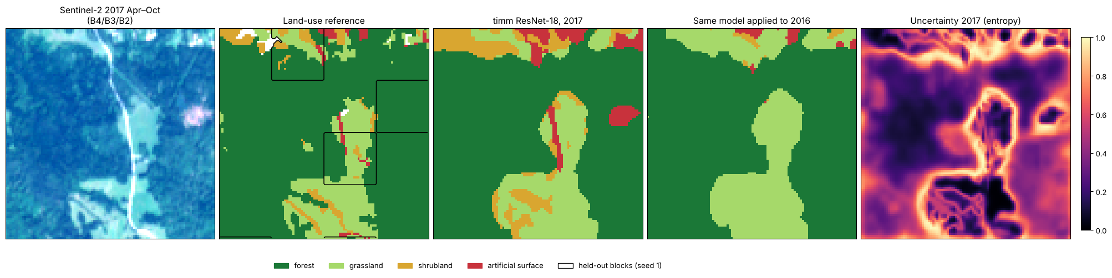
Figure 2. Slovenia: image, land-use reference with held-out blocks, ResNet-18 map for 2017 and for 2016, and uncertainty.
What it showed. Every route works on real data. On such a small area deep learning did not beat the Random Forest: convolutional networks need more labelled area before their use of spatial context pays off. The cirrus band B10 shifted by six standard deviations between years and made one network's 2016 map collapse, which led to the band-shift warning.

3. LandCoverNet Africa, one model per chip
Ten chips of 2.56 × 2.56 km from LandCoverNet Africa (Radiant Earth, CC-BY-4.0) in southern Africa, fetched a few megabytes at a time instead of the whole dataset. In the first run one U-Net was trained and validated per chip, with images that turned out to be mostly from January-March; mean kappa was 0.34. The download now builds wet- and dry-season composites. The best chips, whose images happened to span more of the year, reached kappa 0.75-0.82.
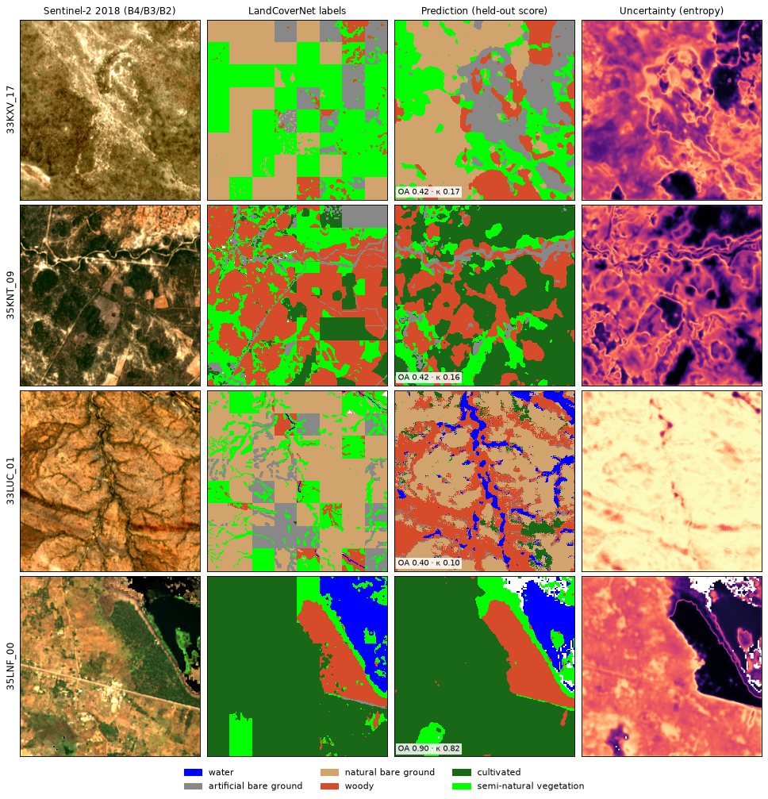
Figure 3. First run, four of the ten chips: image, labels, prediction and uncertainty.

4. LandCoverNet Africa, one model for all chips
One U-Net trained on 7 chips at once (wet and dry season, 20 bands) and tested on 3 chips it never saw, the honest test of transfer to new places.
Chips | Overall accuracy | Kappa
33LYE_20 (training) | 0.93 | 0.85
35LNF_00 (training) | 0.89 | 0.76
other five training chips | 0.55-0.67 | 0.06-0.39
34LHJ_15 (unseen) | 0.64 | 0.35
33KXV_17 (unseen) | 0.46 | 0.10
35LMC_06 (unseen) | 0.37 | 0.01
All unseen chips together | 0.49 | 0.23
Table 7. Pooled run, 21 October 2026.
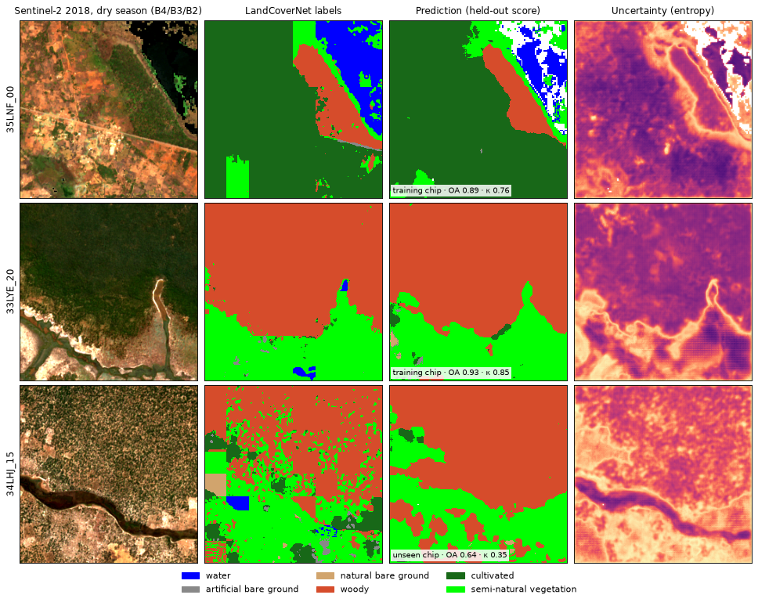
Figure 4. Pooled model on two training chips and one unseen chip (bottom).
What it showed. Transfer is the hard part: a model that maps its own chip well reaches kappa 0.23 on new chips. The model overfitted after 3 of 40 epochs and fell back to the dominant class of each landscape; the uncertainty map is high exactly there. More chips, fewer epochs and pretrained encoders are the next things to try.

5. Tutorial data, Zambia
The tutorial download worked: four cloud-free or suitably cloudy scenes from 2024, WorldCover and two Nigerian flood chips. Dynamic World on the late-August scene called 78% of the area bare. That is the season, not a fault: the miombo woodland is leafless and the grass dry, and Dynamic World labels a single date while WorldCover is an annual map. The tutorial now runs land cover on the April scene first.
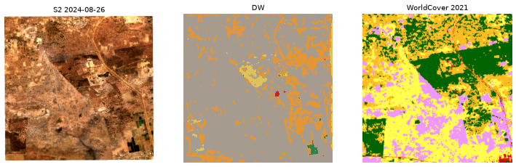
Figure 5. Late-dry-season Sentinel-2 image, Dynamic World, and ESA WorldCover 2021 for the same area.

6. Code review for generalisation
A systematic review of the code found and fixed problems that stopped models from working on new data:
Problem | Effect | Fix
Burn-scar model got inputs 10,000 times too large | The model could not work | The model card's scale now wins over the library default
TerraMind seeded the wrong random generator | A different map on every run | Seeded everywhere
Fill pixels counted as data | Skewed statistics and areas | All-zero pixels are no data
Reflectance stored as 0-1; the 2022 offset | Models saw wrong values | Automatic scaling; offset option and warning
Unnamed bands, missing B8A | Common datasets could not be used | Bands guessed in Sentinel-2 order; stand-ins
One image per training run | Models learned one place and date | Several images, pooled statistics, held-out images, brightness jitter
App kept selecting the uploaded image | Could not switch images | Fixed
Table 8. Main findings of the review.

Limitations
- Only local GeoTIFFs as input for training; reading from STAC catalogues and Earth Engine is not built yet (the tutorial script already searches Earth Search for single scenes).
- No conversion between processing levels: Dynamic World and Prithvi floods need L1C data, the others L2A.
- Trained models transfer poorly to new places with few training images (kappa 0.23 on unseen chips).
- Whole images are loaded into memory, which limits scene size.
- Uncertainty is the model's own confidence and is not calibrated; models can be confidently wrong on unfamiliar data.
- Accuracy is per pixel; area-adjusted accuracy and area estimates with confidence intervals are not computed yet.
- Delineate Anything is AGPL-3.0: a service built on it must publish its source.

Next steps
- Better transfer: more LandCoverNet chips, pretrained encoders and early stopping.
- Satellite archive sources: Sentinel-2 from STAC catalogues by area and dates, and Earth Engine exports (including L1C for Dynamic World), so KAZA scenes can be prepared directly.
- More models: Clay embeddings, SatlasPretrain, and fine-tuning a zoo model on your own labels from the app.
- Architecture comparison over repeated splits and held-out images, with a Random Forest baseline.
- Area-adjusted accuracy following Olofsson et al. (2014), and probability calibration.

Code: MIT licence. Full technical documentation, one note per function, is in the Obsidian vault at docs/vault; the README covers installation and use.

